**The Eleske Pilgrimage** at St. Bernadette’s Mission at Child Lake, held Friday July 8 to Sunday July 10

**Friday** (tentative schedule and events) 8:00 PM Blessing & Feeding of Fire; Drumming; smudging; praying in 4 directions; blessing of the water; Mass

**Saturday** 11:00am Rosary; Noon, prayers at the cemetery; 3:00pm Way of the Cross; 4:00pm healing service; 8:00pm preparations for candlelight procession from church to grotto for evening Mass

**Sunday** 11:00am Sunday Mass at the grotto if weather permits.

Archbishop Gerard Pettipas C.Ss.R. to preside, assisted by Fr. Charles Mugai FMH, pastor.

Little Red River Cree Nation annual pilgrimage: August 4-7th

Lac Ste Anne Pilgrimage is July 26-29th.

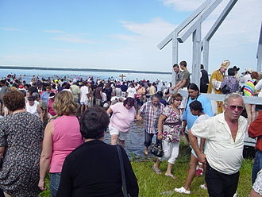

To date (June 30), an official schedule has not been made available yet, except to note that, the pilgrimage will be opened to registered participants only on July 26th with limited access by Park and Ride busses only.

* Camping and/or parking is NOT allowed on the site until the morning of Wednesday July 27th, no exceptions.
* Mass will be presided by Archbishop Gerard Pettipas C.Ss.R., archbishop of Grouard-McLennan at the Lac Ste Anne site on July 27th @ 7:00 pm.



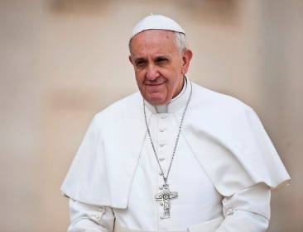

**SUNDAY, 24 JULY 11:20 AM ARRIVAL AT EDMONTON INTERNATIONAL AIRPORT**

**Welcoming ceremonies with Government Officials and other dignitaries. INVITATION ONLY EVENT**

**MONDAY, 25 JULY 10:00 AM MEETING WITH INDIGENOUS PEOPLES:**

**FIRST NATIONS AND INUIT AT MASKWACIS**

**4:45 PM MEETING WITH INDIGENOUS PEOPLES AND MEMBERS OF THE PARISH COMMUNITY OF SACRED HEART OF THE FIRST PEOPLES BY INVITATION ONLY**

**TUESDAY, 26 JULY 10:15 AM CELEBRATION OF HOLY MASS AT COMMONWEALTH STADIUM IN EDMONTON. TICKETS NEEDED**

*Tickets are free, but anyone wishing to attend the Mass will have to reserve a ticket. The public can access tickets through the papal visit website:* *www.papalvisit.ca* *which will provide a direct link to the Ticketmaster.ca portal. Tickets will be available starting Wednesday July 6th @ 10:30am.*

**5:00 PM PARTICIPATION IN THE ‘LAC STE.ANNE PILGRIMAGE’ with LITURGY OF THE WORD**

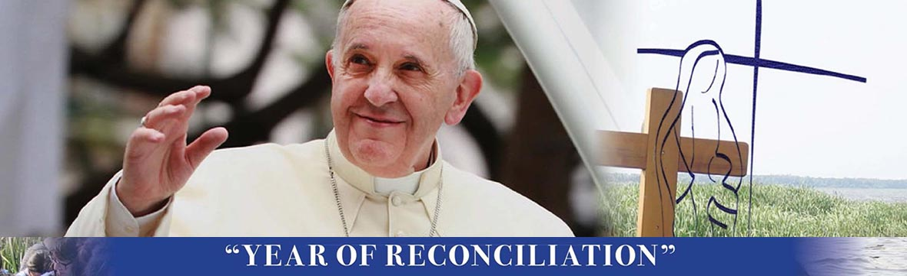

**Lac Ste. Anne Pilgrimage is on July 26-29, 2022**

Note that the pilgrimage will be open to **registered participants only** on Tuesday, July 26thwith **limited access by Park & Ride busses ONLY**. **To allow enough room for the Papal Visit, camping and/or parking is NOT allowed on the site until the morning of Wednesday, July 27**th. Participants will need to arrange camping at other locations before then. No exceptions:

* Camping at Nakota Crossing Camp Site: July 22-26

Passes purchased at Nakota Crossing Site will remain valid and will transfer to Lac Ste Anne Site. All campers must exit Nakota Crossing Site by July 27, 2022

* Camping at Lac Ste. Anne Pilgrimage: July 27-29

*This schedule is regularly updated as soon as we learn of any changes.*

|  |  |  |
| --- | --- | --- |
| Tuesday, July 26 | | |
| **12 noon** | **Pipe Ceremony and Flag Raising** | Alexis Nakota Sioux Nation |
| **5 p.m.** | **Pope Francis Visit of Reconciliation** | National Papal Visit Committee |
| **11:30 a.m.** | **Rosary & Mass** | Alexis Nakota Sioux Nation & Paul First Nation |
| Wednesday, July 27 | | |
| **9:30 a.m.** | **Rosary** |  |
| **10:30 a.m.** | **Rosary & Mass** | Cursillo Community & Sacred Heart of the First Peoples |
| **3 p.m.** | **Mass** | Our Lady of Seven Sorrows Parish, Maskwacis, AB |
| **7 p.m.** | **Mass** | Archdiocese of Grouard-McLennan |
| **8:30 p.m.** | **Twelve Step Pilgrimage and Pledges** | Cursillo Community |
| Thursday, July 28 | | |
| **9:30 a.m.** | **Rosary** |  |
| **10:30 a.m** | **Mass** | St. Theresa Point and Wasagamach, MB |
| **3 p.m.** | **Mass** | Dene Nations of Saskatchewan |
| **7 p.m.** | **Mass** | Métis Nation of Alberta |
| **8:30 p.m.** | **The Way of the Cross – The Living Rosary** | Enoch and Alexander First Nations, AB |
| Friday, July 29 | | |
| **10 a.m.** | **Mass** | Pelican Narrows and Sandy Bay, SK |
| **1 p.m** | **Mass** | Tlicho First Nation, Behchoko, NWT |