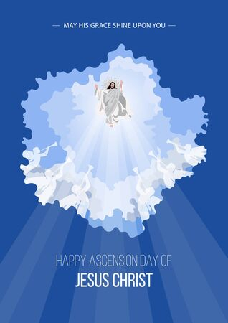

***ST. MARY’S: ST. PATRICK’S: ST. EDMUNDS:***

***HORSE LAKE RESERVE***

**BOX 146 BEAVERLODGE, AB T0H 0C0**

**PHONE: 780-354-2415 FAX: 780-354-2414**

**E-Mail:** **[stmarys1@telus.net](mailto:stmarys1@telus.net)**

**Website: www.stmarybeaverlodge.ca**

**PASTOR: FR. MICHAEL CELL: 780-****814-3471**

**E-MAIL:** **frmichaeldias2006@gmail.com**

**Office Administrator: Nadine Peters**

**Office Hours: Tuesday, Wednesday, Thursday 10am – 3pm**

**Please have Bulletin info to office by 3pm on Wednesdays**

**Archdiocese of Grouard-McLennan website: www.archgm.ca**

***"We are called to nurture Life and Spirit"***

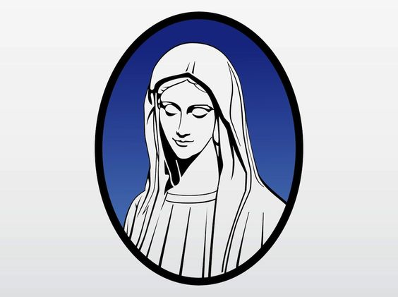

Mass at 8:15am on Saturday, June15, 2024

**MASS TIMES:**

**SUNDAY MASS TIMES AT ST. MARY’S CHURCH:**

**Sunday 11AM and 6:30PM**

**St. Mary’s – Beaverlodge**

**Weekday Mass:** Monday –Saturday: 9:00 AM

**Sunday Mass:** 11:00 AM and 6:00 PM

**First Friday Mass and Eucharistic Adoration**: 9:00am followed by Adoration from 10:00 AM– 1:00 PM

**First Saturday of the Month:** 9:00 AM

**Eucharistic Adoration**: Every Friday immediately after Mass

**Reconciliation:** Confessions will be heard before all weekday Masses, after Sunday Mass and anytime upon request.

**Rosary for Peace ~** The CWL invites all to join them in the recitation of the Rosary on every Tuesday

after the 9:00 AM Mass, St. Mary’s Church

**Meditation:** Every Wednesday at 4:30 PM at St. Mary’s Catholic Church

**Youth Mass**

June 2, 2024.

**School Mass**

May 30, 2024

**St. Edmund’s – Hythe**

1st, 3rd, & 5th Sundays: 9:00 AM

2nd and 4th Sunday Mass will be celebrated on Saturday at 7:30 PM

All are welcome.

**St. Patrick’s – Rio Grande**

2nd & 4th Sundays: 9:00 AM

1st, 3rd, & 5th Sunday Mass will be Celebrated on Saturday at 7:30 PM

**Parish Pastoral Council:** The 2nd Tuesday of every month at 5:00 PM

**Parish Finance Council:** As announced.

**Catholic Women’s League** **Beaverlodge:** First Saturday of each month at 10 AM, Church meeting room

**Knights of Columbus:** 3rd Saturday – 2:00 PM

ASCENSION OF THE LORD, May 12, 2024

**BAPTISM:** Sacraments: Parents are required to complete a Baptism course for each of their children.

Contact the parish priest/parish office minimum before 2 months for preparation and arrangements. **MARRIAGES:** Please contact the rectory tomake arrangements and to begin marriage preparation at least six months prior to the desired date. **OCIA AND ANY OTHER SACRAMENTS:** Please contact the Parish office at 780.354.2415 or Email: stmarys1@telus.net

**THIS WEEK**

Monday ~ OUR LADY OF FATIMA

Tuesday ~ St. Matthias the apostle

Wednesday ~ St. Isidore the Farmer

Thursday ~ Blessed Vladimir Ghika

Friday ~ St. Pascal Baylon

Saturday ~ St. Felix of Cantalice, Pope St. John I



*The Archdiocese of Grouard-McLennan is continuing their monthly magazine*

***Northern Light****for a third year!*

*The magazine includes in-depth stories, photo spreads and features from Catholic communities across our region. It is a unique resource that is cherished by its readers – don’t miss out!*

*Become a subscriber or renew your yearly subscription for $70 at*[***www.archgm.ca***](http://www.archgm.ca/)*or check your church for a subscription card.*

*Celebration of Holy Mass at 9am*

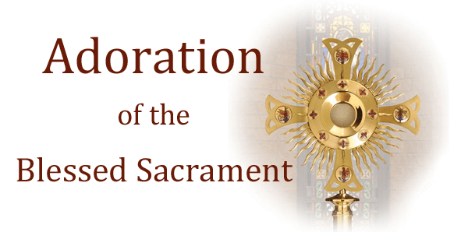

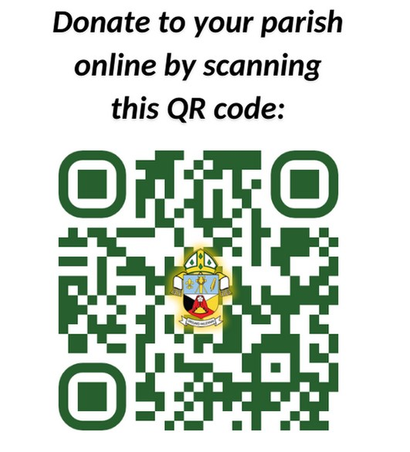

How to Donate to St. Mary’s Parish

Pick-up a box of donation envelopes and register the number with the parish office.

Drop off a PAD application form and a void cheque at the Parish office.

Use this QR Code

Thank you for your generosity and

commitment to your Parish family!

*We will be having Eucharistic Adoration on ever First Friday of each month from*

*10am to 1pm at*

*St. Mary’s Church, Beaverlodge*

*Please sign-up for your hour*

*(at least two people for each hour must attend).*

**Father’s footsteps May 13 - May 18, 2024**

**Monday May 13:** Mass at 9:00AM

Ministry outreach, Beaverlodge Hospital & neighboring communities

Divine Renovation Session

**Tuesday May 14:** Mass at 9:00AM followed by CWL Rosary for Peace

Ministry outreach, Beaverlodge Hospital & neighboring communities

School visit

Sacramental preparations for Children 3:15PM – 4:15PM

Mass at 4:30PM followed by PPC meeting.

**Wednesday May 15:** Mass at 9:00AM followed by Novena

Ministry Outreach Hythe Continuing Care at 10:30AM.

Hythe Pearson Home at 11:45AM

Archdiocesan Faith formation meeting at 1:00PM

Visit to the sick & House bound - Horse Lake First Nations & Hythe

Into the Breach K Of C Session at 7:00PM

**Thursday May 16:** Mass at 9:00AM

WCMA Meeting at 10:30AM

Hythe Pioneer’s Home at 12:30Noon

Visit to the sick & House bound - Horse Lake First Nations & Hythe

**Friday May 17:** Mass at 9:00AM followed by Eucharistic adoration.

Ministry outreach, Beaverlodge Hospital & neighboring communities

Sacramental preparations for Children 3:15PM – 4:15PM

Visit to the sick & House bound.

**Saturday May 18:** Mass at 9:00AM

K Of C Meeting at 2:00pm

*Sunday Mass celebrated on Saturday evening at 7:30PM: St. Patrick’s Church, Rio Grande*

**Sacrament of Reconciliation:** Father will be available for confessions on weekdays half an hour before Mass and upon request. If there is a requirement Sundays after Mass.

**Holy Communion to the sick and house bond, Blessings:** Available anytime upon request.

**Please note:** This is my usual schedule for the week. Unexpected emergencies do pop-up. If you

need to contact me for any needs please feel free to do so. 780-814-3471.

Thank you to all Moms!

**Happy Mother’s Day!**

A Mother’s Prayer

Dear Lord, it’s such a hectic day, with little time to stop and pray

For life’s been anything but calm, since You called me to be a mom

Running errands, matching socks building dreams with building blocks

Cooking, cleaning and finding shoes and other stuff that children lose

Fitting lids on bottled bugs Wiping tears and giving hugs

A stack of last weeks mail to read. So where’s the quit time I need?

Yet when I steel a minute, Lord, just at the sink or ironing board

To ask the blessing of Your Grace, I see then in my small ones face

That you have blessed me all the while, and I stop to kiss that precious smile!



Gentle Reminder to all parish volunteers

Please return all completed volunteer screening forms to Brenda Yamkowy for submission to the Archdiocese as they are requesting them as soon as possible. Thank You warmly, Brenda Yamkowy

Parish Screening Co-coordinator

**Roadside Clean-up Fundraisers**

We are pleased to announce that St. Mary’s Church, CWL and the K of C have all been selected for the 2024 roadside cleanup program!

**Thanks to those who volunteered for K Of C St. Mary’s Church Roadside Clean up TBA**

**Date changed: CWL date Saturday, June 15**

All groups will meet at 9am at St. Mary’s Church for maps, instructions, and necessary items.

*Please find the sign-up sheets located in the foyer of the Church. **SIGN-UP TODAY!**

Hospitality and Accompaniment

**Office of Evangelization & Faith formation**

As part of 2024 OEC’s Divine Renovation initiative for Parish Faith Formation Renewal, the OEC invites all to this special

“Hospitality and Accompaniment Workshop”.

Venue: St. Joseph Parish Hall, Grande Prairie

Date: Saturday, June 8, 2024

Time: 9: 45am – 12:45 am

(Snacks and Lunch will be provided).

Registration at: www.archgm.ca

“I will never forget you”

Come and join us for St. Mary’s Annual Walk for Life

On Sunday, May 26, 2024. We will begin at 1PM!

We will walk or drive to the Highway Parking Lot (10 street Highway 43, located across from the Beaverlodge Hotel) where we will gather and pray the Rosary for Life.



Ten Parish Values

The Parish Ad hoc Committee has created a survey to help start the process of strategic planning for our parish.

Please pick-up a copy of the survey located in the foyer of the church. Please return the completed survey by Sunday, May 12

The next Parish Ad Hoc committee meeting will be held on Monday, May 27th at 7:00PM

Fr. Michael and the committee will keep you updated on this process.

Prayer Vigil for World Peace

May 15, 2024

An Inter-Faith Prayer Service

7:45pm-8:45pm

St. Joseph Catholic Church, Grande Prairie

Everyone Welcome





The Reception of Holy Communion

Please find the archbishop's letter to all the faithful in the archdiocese on the reception of Holy Communion under both forms located at the back of the church.

Please take time to read this message to understand the full details of how we will be re-instituting this practice in our parishes.

An instructive video will also be made available by the archdiocese soon!

Next Parish Pastoral Meeting

Tuesday, May 14, 4:30pm

Beginning with the celebration of the Mass at 4pm



1. Sunday, May 12: Survey forms are due.
2. Tuesday, May 14: PPC meeting at 4:30pm
3. Wednesday, May 15: Inter-Faith Prayer Vigil, 7:45pm-8:45pm, St. Joseph Church, GP
4. Wednesday, May 15: K of C “Into the Breach at 7pm.
5. Sunday, May 26: ANNUAL WALK FOR LIFE beginning at 1pm.
6. Monday, May 27: Ad hoc committee meeting at 7pm, St. Mary’s Church meeting room.
7. Thursday, May 30: School Mass at 9am.
8. Sunday, June 2: Communion Cup restored!
9. Friday, June 7: First Friday Mass at 9am followed by Holy Adoration form 10am-1pm.
10. Saturday, June 8: Hospitality and Accompaniment Workshop from 9:45am-12:45pm at St. Joseph’s Church Grande Prairie.
11. Saturday, June 15: CWL Roadside Clean-up. Please meet at St. Mary’s at 9am.

**Election for PPC Members**

It has been quite a while since we had our last

election for PPC members. This was discussed in our last meeting and a decision was made to go for election and to have our new members on board by June 11th if possible. This is an opportunity for everyone in our parish to step forward to be part of PPC. I encourage everyone to participate in this process of election.

We need and appreciate your input during this process. The method of election will be nomination and as per the polices laid down by the Archdiocesan Parish Pastoral Constitution approved by His Grace on 11th August 2023. More information to follow.

Communion from the Cup

I have chosen the Solemnity of the Most Holy Body and Blood of Christ on June 2nd, also known as Corpus Christi, as the date on which to restore the practice of Communion from the Cup. I am happy to share this good news with you all. We hope you will welcome this news with humble hearts as we prepare to share together in the body and blood of Our Lord, and so unify ourselves ever more intimately as members of His Mystical Body – the Church.

Yours sincerely in Christ the Redeemer,

Most Rev. Gerard Pettipas, C.Ss.R.

Archbishop of Grouard-McLennan

St. Camp Martin 2024 Information

Camp St. Martin is a Catholic Summer Camp, sponsored by the Archdiocese of Grouard-

McLennan, and takes place annually in August. Camp St. Martin takes place on Cardinal Lake, just outside of Grimshaw, at the Camp Artaban Facilities. Camp St. Martin first opened in 2007 as

ArchGM Summer Camps and was rebranded in 2013 taking on the name of our Patron Saint.

Camp Dates:

We will have three jam packed weeks of Camp.

* Lead Week (Gr. 9-12): August 5th-10th
* Jr High Week (Gr. 7-8): August 11th-16th
* Elementary (Gr. 4-6): August 18th-21st

2024 Camp Teaser Video:

2024 Camp Teaser Google Drive Viewing Link

Register at: www.archgm.ca